REFUGEES: HOW THEY “LIVE”

By Daphné BADA – September, 29, 2016

Last May, Paris’ mayor announced the creation of a refugees camp in the North of the city.
September, how do they get to survive and spend more and more days in these makeshift camps?

We wanted to get to know better the settlements, so we made the effort of going to Stalingrad, a well known place in Paris where a mass of refugees are.
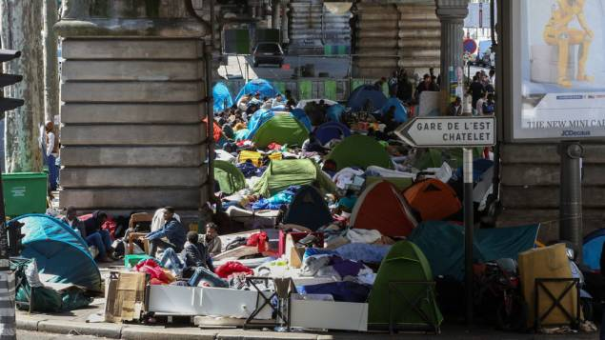
When we first saw it, it didn’t seem like the “place to be”, in fact their habitations were under a bridge. Tents were spread on the whole area. By the look of it, around 10,000 people may live there. The environnement was a bit noisy, the kind of noises that are mixed with voices, voices of people passing by, hopeless voices from humans who have left and lost everything to be safer,and the sound of the not so quiet Parisian traffic. For the less fortunate ones that didn’t have tents, they had to sleep on mattresses, or worst, pieces of cardboard. They lived very close to each other, as if they were in a box, which seems very uncomfortable for them even though they try to get use to it.
A camp of refugees in Paris
These camps are not as big as the ones in Turkey, the country that has been hosting more than 2 million refugees but it is as painful to see people living like this. We observed a couple of refugees at different times of the day: some were asking for money in the streets, other were just wandering around, we also noticed a man seated on the pavement. Was he thinking about his past life? Was he feeling any regrets? Who did he lose? What was his plan for the future? A lot of questions were running through our minds.
As for the citizens living around, a lot were passing around the camps while they were going or coming back from work and ignoring them, almost as if they didn’t exist. We asked a few questions to some of those citizens : what did they think about, did they agree with the decision the mayor made, were they disturbed by it: “I feel bad for all these people, I wish the city could do more for them”, says a young man, “It makes the landscape look awful I don’t think it’s appropriate” a woman around 60 declaimed.
By night we talked to a girl who allowed us to ask her some questions about her past and present history. Sanaa, 17, left Afghanistan with a father and young brother after a bomb hit her family house and killed her mother and younger sister. “Leaving the country was really not easy”, she told us. They had to cross many borders to get there. It took them more than a week, they almost died twice, they traveled in a ship with thousands of refugees like them but around 500 did not make it to the final destination. She explained life in the camp was neither the best nor the worst but at least she felt safe and didn’t fear anymore for her life or her brother’s and father’s safety. While they were on the streets asking for money in exchange of services, she had to stay on the camp to make sure their tent did not get stolen. Sometimes she had to be on the streets alone with her brother: “people feel more sympathy when they see children” she admitted. They did not have food every day. She mentioned “helpers” that would give them a meal once or twice a week. She later told us that she wished her mom was with her to support her because she felt alone even though everyone was in the same situation. She hopes for a better future in Afghanistan and wished things weren’t like that. Sadly things are like that and we wish they were as easy to solve as a math problem.

