The refugees of the subway station Jaures.
By Wydad

The following story takes place in the Parisian metro station Jaures. For few months now there are some unfamiliar neighbours. In fast, the station Jaures shelters new refugees everyday.

Refugees live under a bridge just next to the exit of the subway. Because of the subway there is always a lot of noise. It does not smell good, it smells of pee and it looks like a maze. There are plenty of tents piled on each other, sleeping bags, cards board boxes on the floor...
In the settlement there is no privacy or intimacy, everyone sees everyone. There are large puddles of urine all over the floor, waste and dirt. Although, it is not a fancy neighbourhood the street around the shelter look rather quiet and clean.

During the day nothing special happens, refugees get up between 9am and 11am, they eat breakfast together with bread, cakes, milk, coffee and water.
During the day, men play cards, women talk to each others and children play together until nightfall.

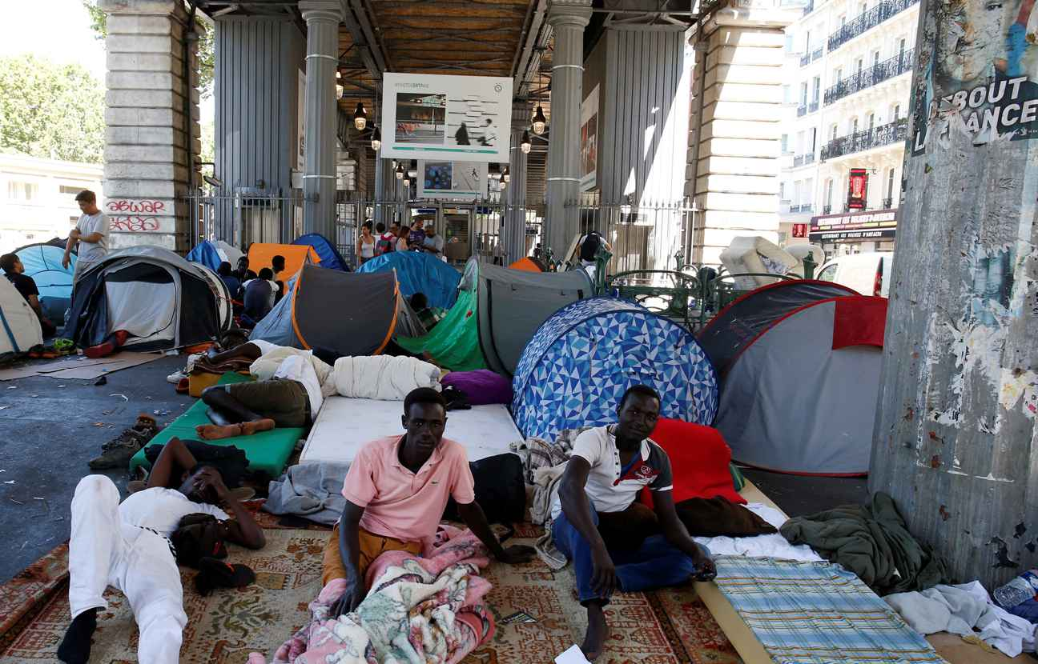

During my visit of the shelter I met a refugee called Kemal, here is story :

" My name is Kemal, I am 26 years old and I am from malian origin.

I had a very long and tiring journey, I crossed unfriendly cities. I swam through the mediteranean sea after our boat broke down and then I walked thousand of kilometers before arriving here. I was tired but the most important is that I arrived safely.

My daily life here is a routine. I can not get a decent job because I am a refugee, I can not get a decent house either. I wake up, eat and stay with the other refugees. Sometimes, I play cards. Often I take my backpack and go for walks in the streets of Paris. I often go near the canal Saint Martin and think about my son who is going to grow up without me. I think about a lot of thinks and dream of a better life and when I finally feel better I go back to the shelter.

Sometimes, I wonder how my life would have been if I had stayed in Mali and studied. Perhaps, I would have had a better life and I would be happy with my family in my home country. But now, I am here and I will do my best to get a better life. "

